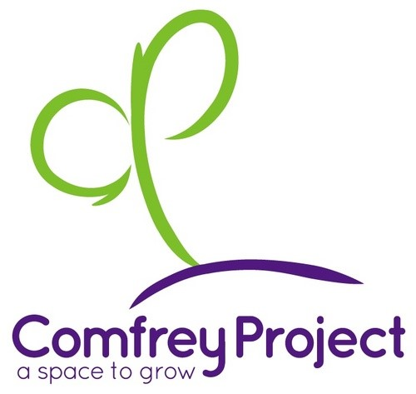GIFT AID DECLARATION FORM
Please tick this box to confirm you are agreeing to sign up to the Gift Aid Scheme

Donation Amount | £ | Date | ___ / ___ / ___
My Details
Full Name
Address
Postcode

- I confirm that I am happy for all gifts of money that I have made to The Comfrey Project in the past 4 years and all future gifts of money that I make to be Gift Aid donations. The Comfrey Project will reclaim 25p of tax on every £1 I give.
- I am a UK taxpayer and understand that if I pay less Income Tax & Capital Gains Tax in the current tax year than the amount of Gift Aid claimed on all of my donations across all Charities, it is my responsibility to pay any difference.
- Gift Aid is reclaimed by The Comfrey Project from the tax I pay for the current tax year.
Please Note:
- You can cancel this declaration at any time by notifying The Comfrey Project.
- If in the future your circumstances change and you no longer pay tax on your income and capital gains equal to the tax that all charities reclaim, you can cancel your declaration.
- If you pay tax at the higher rate you can claim further tax relief in your Self-Assessment tax return.
- If you are unsure whether your donations qualify for Gift Aid tax relief, please ask us, or refer to the help sheet IR65 on the HMRC web site - www.hmrc.gov.uk
- Please notify us immediately if you change your name or address.

We would like to keep you informed about the work you are helping make possible. If you do not wish to receive any further information from The Comfrey Project, please contact us on 07795 320 706 or by emailing info@thecomfreyproject.org.uk. The Comfrey Project will not pass on your details to any other organisation.
The Comfrey Project is a registered Charitable Incorporated Organisation (CIO) no. 1175224.

